Local Art Resources for Parents


http://www.bricktonartcenter.org/

 School of the Art Institute of Chicago
http://www.saic.edu/continuing_studies/welcome/index.html


http://www.artic.edu/aic/


http://www.mcachicago.org/

http://www.evanstonartcenter.org/


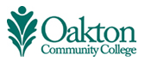
http://www.oakton.edu/museum/


http://www.oakton.edu/cont_ed/all/index.html

