Art Resources Online for Parents

JUST FOR KIDS
http://www.princetonol.com/groups/iad/lessons/middle/for-kids.htm

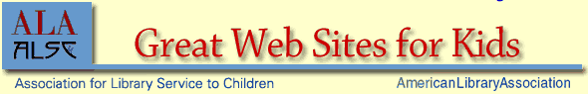
http://www.ala.org/gwstemplate.cfm?section=greatwebsites&template=/cfapps/gws/displaysection.cfm&sec=4


http://www.surfnetkids.com/directory/Art_Music/


http://www.moma.org/momalearning/artsafari/index.html


http://www.haringkids.com/


http://www.auntannie.com/

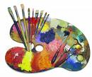
http://www.ischool.utexas.edu/~vlibrary/edres/pathfinders/wood/bib.html

http://www.karscot.com/kidlinks.html


http://kids.niehs.nih.gov/gallery.htm

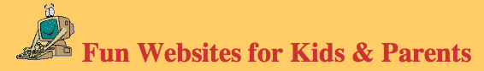

http://www.montgomeryschoolsmd.org/schools/cresthavenes/kidsites.html

