OVERV
I
EW
Lesson 1. Water! Water! Everywhere!

Time—Five 30 minute class periods.

Big Idea
When hot and cold, water takes many different forms.

Essential Questions
What does it mean to “change”? Why do things change? Can something change and yet stay the same?

Objectives

- Students will observe and identify various forms of water as they view common examples in the classroom and in pictures or video clips.
- Students will classify examples of water, according to observable characteristics, using images manipulated at their desk or on a SMART board.
- Students—in a written response—will state the properties of hot and cold as the key reason why water changes form.
- Students will show an appreciation for scientific inquiry as a way to help them describe their experience of water in the natural world.

Materials and Preparations
Before the first class session, make sure you have a way to keep the ice cubes frozen. You may use a small ice cooler or large Ziploc bag sealed shut.

- A pitcher of drinking water
- A few large ice cubes
- PPT of water images/video clips
- LCD projector or SMART board to project PPT or other images/video clips
- SMART board activity for classifying examples of water
- Science journal and pencil (1 per student)

ENGAGE
EXPLORE
EXPLA
I
N
ELABORATE
EVALUATE

ENGAGE (Session 1)

- Invitation—Share a memorable experience, interesting thought, or other personal connection you have had with water (visiting a beach, swimming at the local pool, getting caught in the rain without an umbrella, getting drenched by a water park ride, etc.).

- Continue to share your fascination with water. Show students an empty glass. Pour drinking water from a pitcher into the glass. Add a few large ice cubes. Ask the class—Do you think I can drink all this water in ten seconds? Drink the water as students count. Upon finishing the drink, ask—Boys and girls, how did I do? Is all the water gone?

- Finish drinking the water if necessary. Then invite students to enter into a discussion about this asking—Is all the water really gone? Allow for sufficient wait time and provide hints until students share the notion that ice is made of water too. Ask—How do we know that ice is a type of water? Ask—How is drinking water different from ice? How are the two similar? Some students may note that if you allow an ice cube to melt, it will turn into water. This would provide evidence that ice is made of water.

- Engage moment—Engage student thinking in the following manner. So there are two types of water: right class? The water we drink and the ice cubes that will make the drink cold. Water and ice cubes. That’s it. Hmm, I wonder if that IS it? Are there other types of water? Can you think of any other examples? Does water come in any other form? What do you think? Get out your science journals . . .
Pre-assessment—Instruct students to take out their science journals and copy the word—Water—at the top of the page. Then have students begin a list, recording the examples of “drinking water” and “ice cubes”. Students may draw a picture of these as well. Then prompt students to spend a couple of minutes, by themselves, to list any other examples of water. Instruct students to write the word, as best they can, and to draw a picture alongside the word. When the time is up, have students draw a line under their list to show they are done.

Collaboration—Have students work with a partner to share their responses and to spend an additional 5 minutes adding more examples to their lists. When time is up, invite students to share their responses with the whole class. Record all responses on the board or on chart paper. Point out where students agree or disagree in their examples. Then suggest that perhaps the class still hasn’t found every possible example of water. Ask students to suggest a question that would help the class continue this inquiry—a question the whole class can investigate. Provide time for discussion.

Inquiry Question—After some discussion, lead the class toward a question that can be investigated in class and, in the end, will help students more fully comprehend the big idea of the lesson (when hot and cold, water can take many different forms): What activities can we do in class to help us identify and describe all the forms water can take?
ENGAGE
EXPLORE
EXPLA
I
N
ELABORATE
EVALUATE

EXPLORE (Session 2)

- Setting the stage for investigation—Refocus student thinking by having students recall the inquiry question. Then have students record an abbreviated version of the question in their science journals:
What forms can water take?
- And add—Can you name them all? Announce to the class that you have planned a scientific investigation to help them identify and describe more examples of water.
- Assign partners. Explain to students that they will work with their partner to answer the question.

- Take the opportunity to explain that scientists are like detectives. What do scientists and detectives have in common? They try to answer a question or solve a mystery. They conduct an investigation.

- Describe the investigation. Tell students that they will see pictures of places and things. Explain that their job will be to try to identify (name) anything they see that is made of water. Then explain that whether they can name the type of water or not, they should also try to describe the type of water shown in each picture. Have students note that some picture might have more than one type of water in the picture.

- Project images of various forms of water using the PPT presentation. Show images only (see words and thumbnails below) and any other images or video clips you would like to show students. If showing a video, make sure you mute the narration so as to enable the students to work as scientists do: making observations of the natural world. Using observation skills and prior knowledge, students will try to identify the following:

rain icicles snow snow cone frozen pond
cloud fog frost snowman puff of moist breath
ocean steam hail ice rink water drop & dew
iceberg tear puddle waterfall moisture on mirror
mist hoarfrost rain cloud snow flakes ice on windshield
ENGAGE
EXPLORE
EXPLA
I
N
ELABORATE
EVALUATE

- Allow time between slides. This will give students the opportunity to discuss the pictures with their partner before recording their observations in their science journals. Do not provide answers for students.

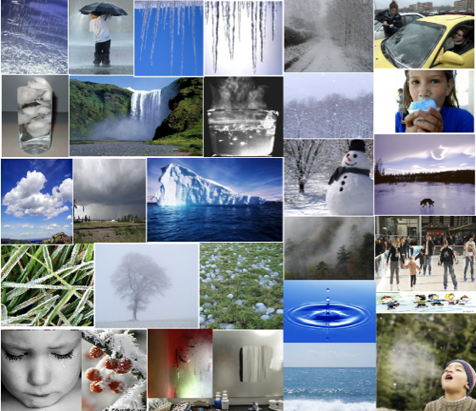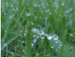

- Lead a class discussion of student responses to the inquiry question--What forms can water take? Record students’ observations and ideas on the board, or chart paper, making sure to use the words offered by each pair of students.

- Ask probing and clarifying questions, pointing out areas of agreement or disagreement among the students.

- End the investigation by noting that the class needs more information to answer the inquiry question. Announce how much you are looking forward to the next science class when you will be able to help students explain an answer to this question more completely.

ENGAGE
EXPLORE
EXPLA
I
N
ELABORATE
EVALUATE

EXPLAIN (Session 3)

- Reconnect students to the students’ preliminary answers to the inquiry question—What forms can water take?—and quickly review the results of the investigation.

- Announce that by the end of today’s class, students will be able to state an important big idea about water, that . . .

When hot and cold, water can take many different forms.

- Correctly identify for the class all the different forms of water presented during the previous investigation. Go through each, one at a time, using the same PowerPoint images, this time presented with correct terms.

- Take time to point out all the observable qualities of water in each image.

- Emphasize the word that names each example of water, and point out each new term to help build students’ sight vocabulary.

- Build an awareness of the many diverse forms of water. You could even suggest the idea that water is very fancy!

- Conclude by restating the following big idea about water: When hot and cold, water can take many different forms.

- Suggest a related idea students might consider, that—Even though water can take many different forms, it’s still water.

ENGAGE
EXPLORE
EXPLA
I
N
ELABORATE
EVALUATE

ELABORATE (Session 4)

- Share a sense of amazement that water can take so many different forms and yet still be water.

- Share also your sense that some examples of water, though different, are alike. Show the following example:

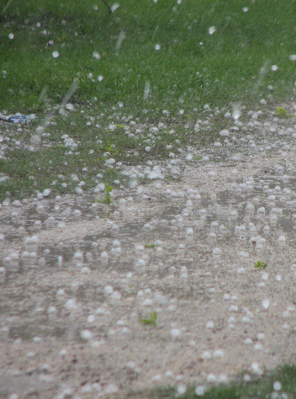
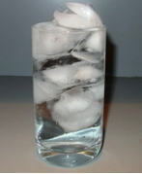

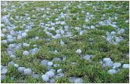

ice cubes hail

- Share some sense of wonder about this.

- Introduce a new question based on this observation: In what ways are certain types of water like other types?

- Divide students into pairs again. Then distribute to students previously seen images of water. Ask students to group the images in a way that make sense to them. Explain to students that “classifying” is the word we use when we think about putting objects into groups.

- Encourage students to use the new vocabulary as they discuss with their partners ways they would classify the types of water.

- Have students share their reasons for the way they classified the images of water. Affirm students ideas.

- Explain that scientists often use “hot and cold” to classify water. When water is very cold, it freezes. Ask students if they can name the examples of water that show frozen water.

- Allow students time to rearrange their pictures. (Images in this group would include ice cubes, ice on the windshield, hoarfrost, snow, frost on grass, snow cone, frozen pond, ice rink, snowman, icicles, and hail).

ENGAGE
EXPLORE
EXPLA
I
N
ELABORATE
EVALUATE

- Explain that when water is not too hot and not too cold, it is found as a liquid (water that we drink). Ask which examples show water as a liquid? Once more, allow students time to rearrange their pictures. (Images in this group would include rain, the glass of water, moisture on a mirror, water in a pot, waterfall, a tear, the ocean, a drop of water and the pool of water).

- Explain that when water is hot enough, it goes into the air and becomes invisible. This is called water vapor. Ask which examples of water show water as vapor, water that is very hot? Again, allow students time to rearrange their pictures. (Images in this group include the water vapor rising from the pot of boiling water. Students might also include clouds, fog, mist, and a puff of moist breath in cold air. However, point out to students that in these examples, water vapor is invisible when it first goes into the air. It then reappears and floats in the air when it starts to get cool).

- Congratulate students on remembering the new vocabulary words that name types of water. Encourage students to continue to think about how examples of water can be classified.

- Point out how water changes when it gets hot or cold. When it gets cold enough, water can freeze and turn to ice. When water gets warm enough, it will melt and turn to a liquid. When water gets very hot, it will turn to water vapor and disappear. When water vapor gets very cold, it can freeze and turn into a cloud. When a cloud gets warm enough, it will turn to rain.

- Finally, provide students with the opportunity to reflect on their observations of water. Discuss how scientists make observations to learn about the world. Point out that scientists enjoy thinking about the observations they make.

ENGAGE
EXPLORE
EXPLA
I
N
ELABORATE
EVALUATE

EVALUATE (Session 5)

- Tell students that they will have the chance to show how much they have learned about water.

- Explain that each student will be given a paper “quiz”. On the quiz, they will answer some questions to show that they can identify and classify different examples of water. They will also answer a question about how water changes.

- Administer the final assessment.

Final Assessment

Name____________________________________________

1. Circle the iceberg. A. 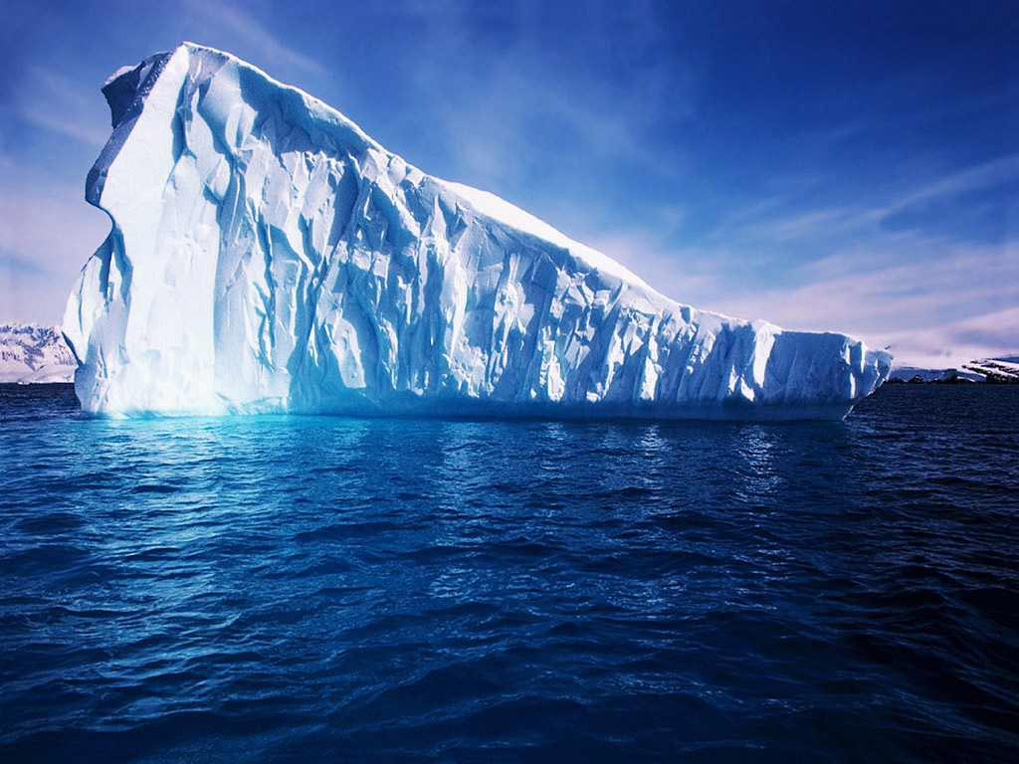 B. 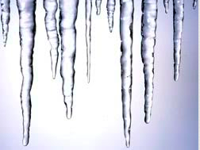

2. Circle the hoarfrost. A. 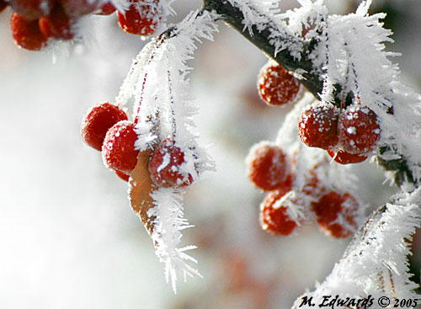 B. 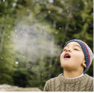

3. Circle water vapor. A. 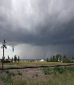 B. 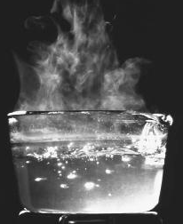

4. Circle the fog. A. 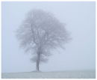 B. 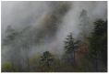

Final Assessment

Name _____________________________________________

5. Circle all the examples of water that is frozen.

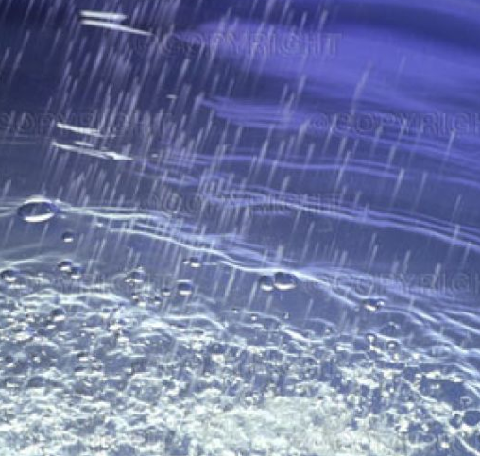
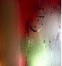

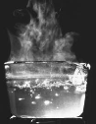

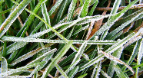

Final Assessment

Name ___________________________________________

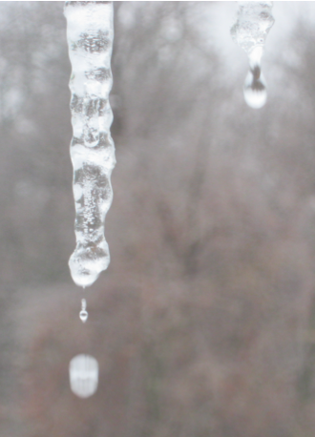

6. Look at the picture.
Why does water change?
Write your answer.

Final Assessment
Name ___________________________________________

Scientists learn by observing. Say how you enjoyed making observations when learning about water.

Final Assessment Key

- A
- A
- B
- A
- Circle all the examples of water that is frozen.
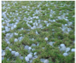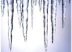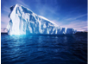

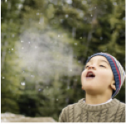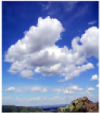
Possible, higher level answers: in these two examples, water goes into the air as vapor, disappears, and then freezes in the air as a cloud.

- Possible Responses . . . When water gets hot enough, or cold enough, it can freeze, melt, or disappear into the air.
More Possible Responses . . . When it gets cold enough, water can freeze and turn to ice. When water gets warm enough, it will melt and turn to a liquid. When water gets very hot, it will turn to water vapor and disappear into the air. When water vapor gets very cold, it can freeze and turn into a cloud. When a cloud gets warm enough, it will turn to rain. When ice cubes get warm, they melt and turn to liquid water.

Scientists learn by observing. Say how you enjoyed making observations when learning about water. Answers will vary.

