Mission Trip Takes Academy Students to Jamaica
Posted Tuesday, May 3, 2016
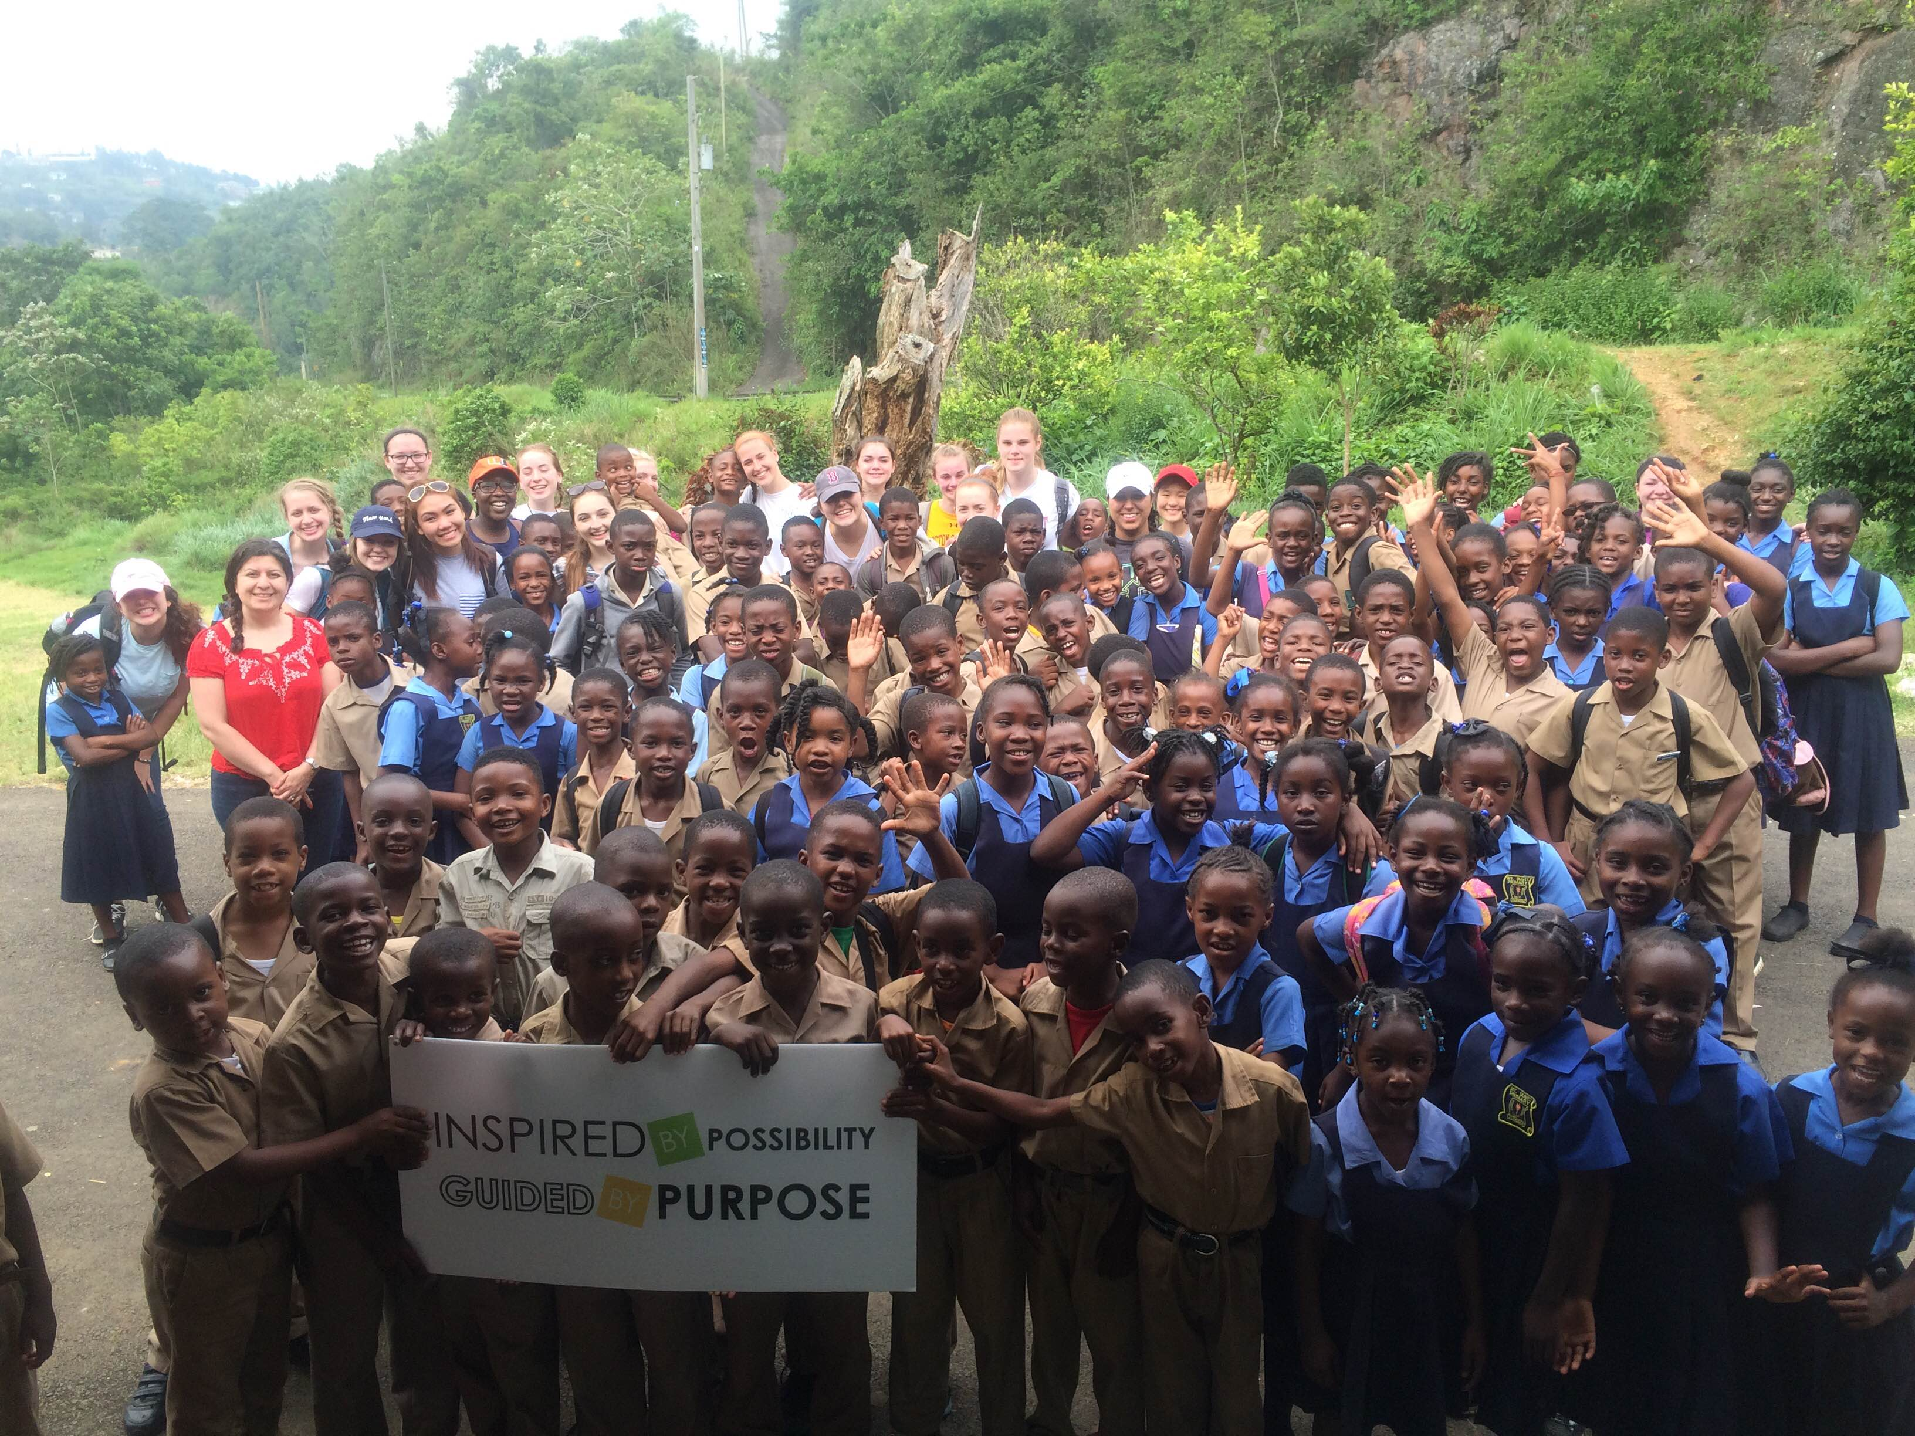
The thought of heading to Jamaica on spring break conjures up visions of relaxing on white sand beaches by crystal blue waters.

This April vacation though, a group of eighteen students and two chaperones from the Academy of Notre Dame traveled to Jamaica for a different reason.

The eight-day vacation was a service trip planned through the Academy's Mission & Ministry.

The students spent their first four days volunteering at the Mount Olivet Primary School in the rural farming community of Mandeville. Mount Olivet is a six classroom primary school that educates 126 children from the age of six through 13. The school’s children either have no family or come from single-parent households. Academy students assisted the Mount Olivet teachers in the classroom working to improve the children’s numeracy and literacy skills. They also helped to design and paint a mural on the outside of the school building.

“We were all transformed by the relationships we built with the children at the school, with the JVE staff, and with each other,” said Hope Griffin, director of Mission & Ministry at NDA.

Day five of the trip found the group hard at work farming with the locals of Mandeville and learning how to cook like a Jamaican.

The last leg of the trip was all about cultural immersion. The students traveled to Montego Bay where they toured the Rastafari Indigenous Village and learned about Rastafarian life, history, and traditions. They also attended a service at the Mount Olivet United Church where they joined in fellowship and worship with local community members.

“We had an amazing time in Jamaica,” Griffin said. “The country was beautiful, the food was delicious, and the people were so friendly. It was truly a life-changing week.”

The students who attended the Jamaica Service Trip were:

Mollie Anderson, Billerica, Grade 11
Melanie Boo, Lowell, Grade 11
Lauren Bradley, Tyngsboro, Grade 10
Jane Campbell, Amherst, NH, Grade 11
Eunji Choi, Westford, Grade 11
Cara Fischetti, Groton, Grade 10
Madelyn Hallisey, Pepperell, Grade 12
AnnMarie Kordish, Tyngsboro, Grade 10
Alexia Landry, Dracut, Grade 10
Juliette Lessard-Tetrault, Tyngsboro, Grade 11
Gabriela Llanos, Dracut, Grade 11
Grace Manley, Pepperell, Grade 10
Olivia Marion, Groton, Grade 11
Fiona Martin, Andover, Grade 11
Kayla Massicott, Carlisle, Grade 11
Brigit O'Dwyer, Pelham, Grade 11
Emma Paxton, Groton, Grade 10
Laura Pere, Tyngsboro, Grade 11

Chaperones:

Maria Collins, French/Spanish
Hope Griffin, Director, Mission & Ministry

