Marzano Research Laboratory

Tina H. Boogren

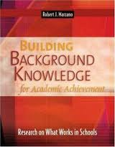

**Academic Vocabulary**

*2.7: Developing Vocabulary: Identifies academic vocabulary aligned to the learning target and uses various strategies for student acquisition*

# Macintosh HD:Applications:Microsoft Office 2011:Office:Media:Clipart: Business.localized:BU005376.png**Outcomes**

* Learn how to boost the academic performance of all students through focused instruction in vocabulary.
* Understand the difference between general and academic vocabulary and how vocabulary learning relates to building background knowledge.
* Learn a process for creating a list of essential academic terms and phrases within a content area and a six-step process for teaching academic vocabulary.
* Discover how to utilize a list of basic and advanced vocabulary terms with English learners, as well as specific vocabulary games to enhance student engagement with vocabulary instruction.

**Definitions**

* **Background knowledge:** What a person already knows about a particular topic.
* **Academic vocabulary:** Vocabulary that is considered to be critical to understanding the concepts taught within an academic subject areas. ↵
* **Basic vocabulary:** Vocabulary that is critical to understanding and using the English language.
* **Advanced vocabulary:** Vocabulary that is critical to general literacy development.

***Additional Notes:***

***Suggested Activities to Implement Effective***

***Vocabulary Instruction:***

1. All teachers participate in training on vocabulary instruction.
2. All teachers create lists of essential words for units of study.
3. Students will be pre- and post-tested on these lists.
4. All students create and use vocabulary journals in their classes.
5. All teachers participate in PLC activities focused on vocabulary.

*The more general background knowledge a student has about the academic content that will be addressed in a given class or course, the easier it is for the student to understand and learn the new content addressed in that class or course.*

If a district (or school) were to systematically ensure that all students were exposed to specific academic terms and phrases across the grade levels, this would form a strong common foundation for all students.

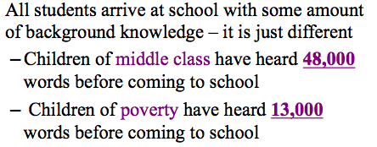

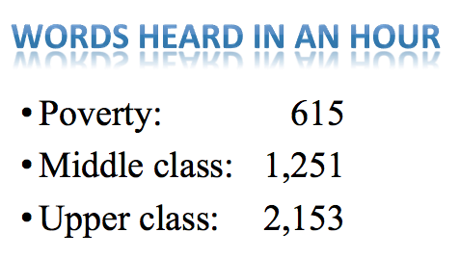

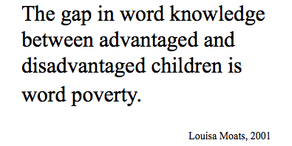

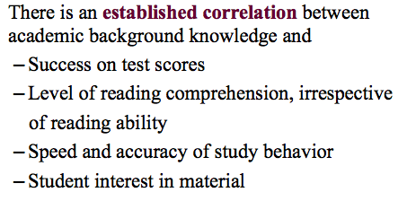

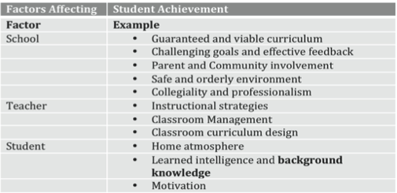

* Research shows a student in the **50th percentile** in terms of ability to comprehend the subject matter taught in school, with no direct vocabulary instruction, scores in the **50th percentile** ranking.
* The same student, after specific content-area terms have been taught in a specific way, raises his/her comprehension ability to the **83rd percentile**.

**TAKE AWAY: FOR ALL STUDENTS, DIRECT INSTRUCTION OF VOCABULARY WORKS!**



*Additional Notes:*

*Identify critical terms and phrases then use a research-based process for teaching new terms and phrases.*

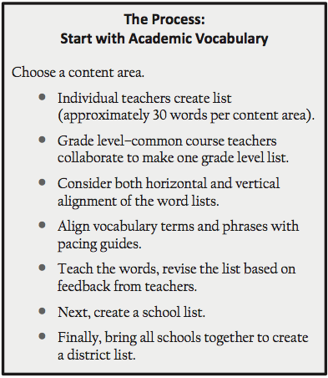

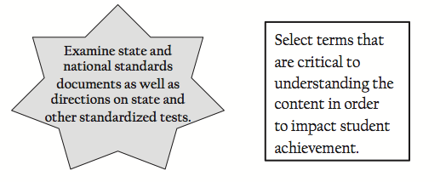

***It is very important to re-visit and re-test words.***

***For retention purposes, you should:***

* Use the words in classroom conversations one to two weeks prior to direct instruction.
* Mention each word ten times during that week.
* Require students to use the words (e.g., Write a sentence using two of the vocabulary words.).
* Spiral your assessments to include words from previous weeks.

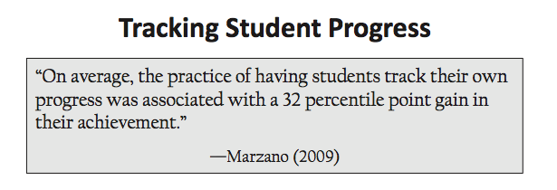

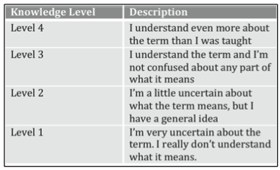

***Tah-daaah…* The Six-Steps to Teaching Vocabulary:**

|  |  |  |
| --- | --- | --- |
| *Provide a description, explanation, or example of the new term.*  *Notes:* | *Ask students to restate the description, explanation, or example in their own words.*  *Notes:* | *Ask students to construct a picture, symbol, or graphic representing the term or phrase.*  *Notes:* |
| *Engage students periodically in activities that help them add to their knowledge of the terms in their notebooks.*  *Notes:* | *Periodically ask students to discuss the terms with one another.*  *Notes:* | *Involve students periodically in games that allow them to play with terms.*  *Notes:* |

**ELL students: **

**Step 1:** Provide a description, explanation, or example of the new term (along with a nonlinguistic representation).

**Step 2:** Ask students to restate the description, explanation, or example in their own words in their own language.

**Step 3:** Ask students to construct a picture, symbol, or graphic representing the word or phrase. Students should create their own representation and not copy yours from Step 1.

**Step 4:** Engage students periodically in activities that help them add to their knowledge of the terms in their notebook. Allow students to use their native language as much as possible.

**Step 5:** Periodically ask students to discuss the terms with one another. Pair students of the same language together.

**Step 6:** Involve students periodically in games that allow them to play with terms. Pair students of the same language together.

***Additional Notes:***

**Samples**





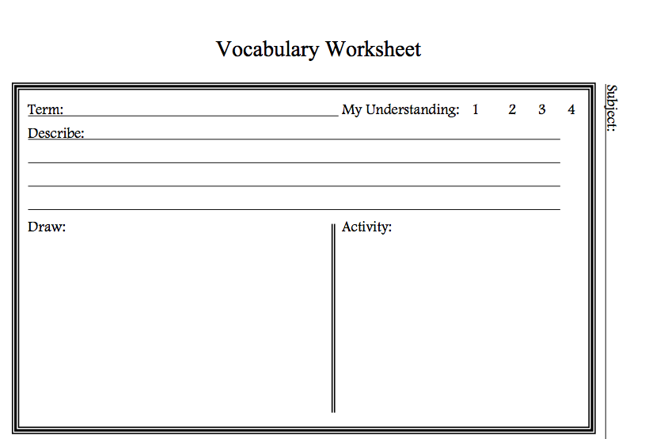

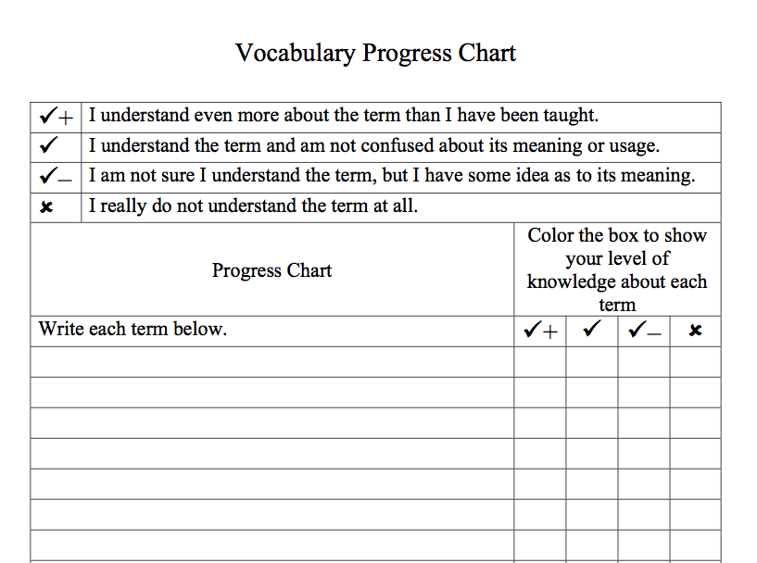

**Websites to check out:**

[**www.marzanoresearch.com**](http://www.marzanoresearch.com)

[**www.wordia.com**](http://www.wordia.com)

[**www.visuwords.com**](http://www.visuwords.com)

[**www.toondoo.com**](http://www.toondoo.com)

[**www.makebeliefscomix.com**](http://www.makebeliefscomix.com)

[**www.snappywords.com**](http://www.snappywords.com)

[**www.freerice.com**](http://www.freerice.com)

[**www.confusingwords.com**](http://www.confusingwords.com)

[**www.visualthesaurus.com/vocabgrabber.com**](http://www.visualthesaurus.com/vocabgrabber.com)

[**www.wordle.net**](http://www.wordle.net)

[**www.cybraryan.com/vocabulary.html**](http://www.cybraryan.com/vocabulary.html)

[**www.freetech4teachers.com**](http://www.freetech4teachers.com)

[**http://esu4vocabularystrategies.wikispaces.com/**](http://esu4vocabularystrategies.wikispaces.com/)

**http://sde.state.ok.us/curriculum/BAV/default.html**

***Others:***

*“The limits of your language are the limits of your world. All I know is what I have words for.”*

-Ludwig Wittgenstein

***References:***

Marzano, R. J. (2009). *Teaching basic and advanced vocabulary: A framework for direct instruction*. Florence, KY: Heinle (Cengage Learning) and Alexandria, VA: Association for Supervision and Curriculum Development.

Marzano, R. J., & Pickering, D. J. (2004). *Building background knowledge for academic achievement: Research on what works in schools.* Alexandria, VA: Association for Supervision and Curriculum Development.

**Thank you!**

**Tina Boogren, Marzano Research Laboratory**

[**tinaboogren@live.com**](mailto:Tina.Boogren@marzanoresearch.com)

[**www.marzanoresearch.com**](http://www.marzanoresearch.com)